31st Annual International SFF Symposium
Meeting Agenda
Monday, August 17, 2020
All Times are Central Standard Time (GMT -5)

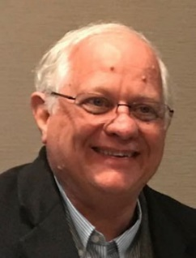
8:00-8:15 Opening and Introduction, Dave Bourell and Carolyn Seepersad
The University of Texas at Austin

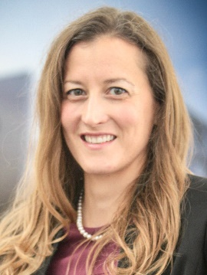
8:15-8:45 COVID-19: A Tipping Point for Additive Manufacturing
Laura Gilmour, EOS North America
In the wake of COVID-19, the manufacturing industry has been turned upside down. In a world of fixed supply chains and complex logistics, the mega factories we rely on are incredibly unprepared. Manufacturing is not a cure for COVID-19, but with the shortages of basic medical products like PPE, respirators, and testing swabs it’s clear that manufacturing is an important cog in the machine needed to battle the virus. As supply chains were disrupted by the virus, the entire ecosystem of additive manufacturing providers quickly mobilized to meet the needs of critical hospital equipment and PPE to protect healthcare workers on the front lines. EOS mobilized its team of medical experts to provide assistance and support to our customers and meet these critical needs at the point of care. Join us for this talk as we highlight a few of the most impactful solutions enabled by additive manufacturing in the fight against COVID-19.

8:45-9:15 Towards a Defect-based Process Map
Tony Rollett, Carnegie Mellon University
Although the outlines of a defect-based process map for powder bed fusion additive manufacturing (AM) have been in place for some time, many of the details remain to be defined. At low speeds, keyholes become unstable and shed pores. Computer vision helps to quantify this transition in terms of keyhole depth and aspect ratio based on high speed synchrotron x-ray visualization. Lack of fusion porosity is dominated by (lack of) melt pool overlap which is seemingly straightforward but subtly dependent on melt pool shape. For the latter, direct visualization provides unique insight into the laser penetration such that the effective absorptivity varies with power density. At high speed and power, fluid flow behind the heat source often causes pile-ups that become frozen in place, resulting in severe variability in melt pool dimensions. Tomography or sectioning reveals defect structures and machine learning again provides new tools for analysis of defect structures.
9:15-9:45 Light-matter interaction, melt pool dynamics and solidification behavior in laser powder bed fusion processes
Manyalibo J. Matthews, Lawrence Livermore National Laboratory
In this talk I will review recent developments in understanding and controlling light-matter interaction and material response associated with laser powder bed fusion additive manufacturing. Complex hydrodynamics driven by vapor recoil, Marangoni convection and vapor flow entrainment have been probed in recent years using high speed optical and x-ray imaging, yielding unprecedented insights into the process. Further insights to solidification dynamics and solid-solid phase transitions have been enabled by in situ x-ray diffraction which can inform site-specific microstructure control for mechanical performance optimization. As part of the critical assessment of the physics of the process, validated hydrodynamic finite element model simulations have proven to be extremely valuable and can be used to inform rapid solidification microstructural models. This combination of validated modeling and detailed experimentation has led to new approaches to process optimization that can improve material properties and part performance. Prepared by LLNL under Contract DE-AC52-07NA27344.

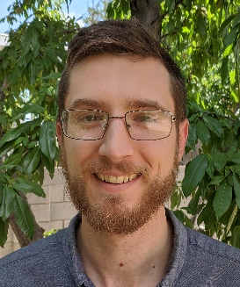
9:45-10:15 Contacting but not Connected: Interpenetrating Lattices
Benjamin White, Sandia National Laboratories
Traditional lattice metamaterials have greatly expanded the range of achievable material properties; however, they are generally physically continuous throughout their volume, and thus cannot take advantage of contact interactions or multi-body behavior. Here we present the new concept of interpenetrating lattices, where two or more lattices interlace through the same volume without any direct connection to each other. Interpenetrating lattices greatly expand design possibilities, allowing single material printers of all types to print composite metamaterials irrespective of material or length scale. While the geometry defining interpenetrating lattices has been studied since the days of Euclid, additive manufacturing allows us to turn these mathematical concepts into physical objects with remarkable properties including reduced transmission of thermal, electrical, shock and vibration loads, increased toughness, multi-stable/negative stiffness behavior, and unusual energy transduction.
10:15-10:30 Short Break
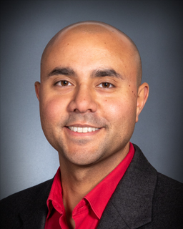
10:30-11:00 FAME Presentation: Towards building a perfect part – Some progress on metal additive manufacturing design, sensing, control, and inspection
Abdalla R Nassar, Edward W Reutzel, David J Corbin, Christopher Stutzman, Brett Diehl, Zack Snow, Andrew Przyienmski , Baily Thomas, Adnen Mezghani, Corey Dickman; Penn State University
Can we ever achieve the goal of building a perfect additively manufactured (AM) part? That is, a part that, despite its arbitrary complexity, is true to the intended geometry, density, microstructure, and, most-importantly, performance predictions. Perhaps the answer is yes, but there is still quite a ways to go. Recent works by the co-authors and others on process and part design, in-situ sensing and control, and post-process inspection will be highlighted, with a focus on recent efforts to identify, generate, and mitigate flaws in directed energy deposition and powder bed fusion AM. Our results demonstrate that improvements in part quality are achievable through systematic mitigation of flaw sources. However, significant work remains in identifying pathways for in-situ sensing and control of process perturbations.
11:00-11:30 FAME Presentation: From Rapid Prototyping of Ice Parts to Additive Manufacturing of Advanced Ceramic and Metallic Components
Ming C. Leu, Missouri University of Science and Technology
This presentation highlights the speaker’s journey of additive manufacturing (AM) research. In the mid-1990’s, a ‘cool’ technology named Rapid Freeze Prototyping was invented to produce freeform ice parts by freezing water droplets layer upon layer. By extending the concept of using water as the medium for 3D printing, the process of Freeze-from Extrusion Fabrication was invented to fabricate ceramic parts with complex geometries by extrusion of aqueous pastes of high solids loading in a freezing environment. This was further developed into a high-performance ceramic AM process, named Ceramic On-Demand Extrusion, in order to overcome ice crystal formation and nozzle clogging during the paste extrusion process. Significant research efforts were performed to understand and optimize these environmentally conscious processes, as well as metal AM processes including the Laser Powder Bed Fusion process and the novel Laser Foil Printing process. Some innovative applications of the various AM technologies for the aerospace, energy, biomedical, electronics and other industries are also presented.
11:30 AM Closing Remarks, end of morning session

America Makes Hosted Afternoon Session
Transitioning University Research to Industry
All Times are Central Standard Time (GMT -5)

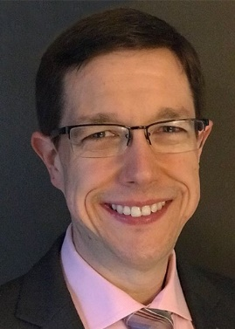
This session highlights how technology can transfer from the university to the private sector. Three presentations emphasize various attitudes and approaches. Dr. Mark Benedict is the AM Lead at the Air Force Research Lab and offers a perspective on the significance of technology transfer for the armed services. Dr. Brent Stucker developed a software modeling system and moved with the spin off to a private company, leaving the university. Dr. Joe Beaman spun off the original laser sintering technology while remaining at the university. We hope that these perspectives will inspire researchers to consider technology transfer as a means of contributing to the advancement of technology.

1:00-1:15 PM Opening Remarks – Brandon Ribic, America Makes

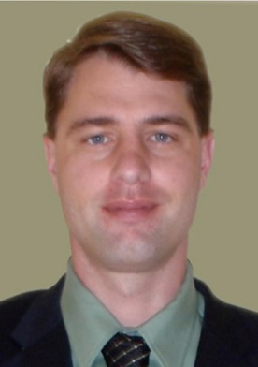
1:15-1:45 PM An Air Force Perspective on AM Technology Transfer
Mark Benedict, Air Force Research Laboratory
Additive Manufacturing has presented particular challenges for technology transfer due to widely distributed nature of research access to production grade equipment. Bridging this gap between novel research and deployed technology is critical to maintaining a strategic technical advantage for the Air Force. An overview of the different Department of the Air Force technology transition stakeholders and the mechanisms they use to identify and support promising technology transition will be presented. These technology transition mechanisms and events will be contextualized with several case studies that demonstrate how AM technology advancement is being supported.

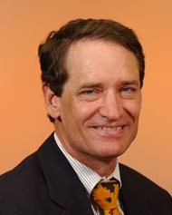
1:45-2:15 PM Moving Additive Simulation from Academia to Industry: The Story of 3DSIM
Dr. Brent Stucker, ANSYS
There is a huge difference between success in academia and success in industry. In academia we convince people to give us money to investigate a promising idea, show that the idea has merit and publish a paper about what we learned about that idea. In industry we must take an idea and make it easily accessible to our customers. There is a huge gap between proving that a concept is feasible and making that concept work consistently in real-life scenarios. Through this talk I will explore how additive manufacturing simulation went from an idea to a tool used in industry on a daily basis.

2:15-2:45 PM History and Origin of Powder Bed Fusion
Joe Beaman, The University of Texas at Austin
Starting in the 1980’s, several new technologies were created that have the potential to revolutionize manufacturing. These technologies are, for the most part, additive processes that build up parts layer by layer. This presentation gives a brief history of one of these processes – Powder Bed Fusion (PBF). Finally, a brief discussion of new methods and future directions of PBF process control is presented.

2:45-3:00 PM Closing Remarks

