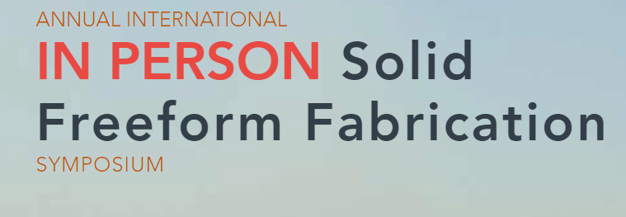
33rd International Solid Freeform Fabrication Symposium- An Additive Manufacturing Conference - July 25-27, 2022

NSF-funded Student Registration Fee Waiver Award Application

Application Instructions
- Read these instructions carefully. Failure to follow them means your application will not be considered for funding. Fill in every field on this form.
- Complete the application, get endorsement from your advisor, then save the PDF file for submission. Filename format is SFFSupport2022_<lastname>_<firstname>.pdf. An example is SFFSupport2022_Doe_John.pdf.
- Submit the pdf file as an attachment in an email to Dr. Guha Manogharan at gum53@psu.edu with the subject line SFF 2022 CONFERENCE SUPPORT <lastname>.
- Application deadline is Wednesday, May 25th, 2022.
- You should be informed of acceptance by Monday, June 6th, 2022.
- Special instruction for SFF 2022: If you have not submitted an abstract for presentation and/or proceedings, you can now submit a POSTER as a second PDF attachment to your application. The poster abstract will be ONLY be accepted if you receive an award.
Awards will directly cover the full student registration fee. Award winners will pay nothing to attend the full meeting but will be responsible for travel costs and lodging. Postdoctoral scholars are not eligible.
Before applying, please note that to qualify for the award you MUST (no exceptions, so please don’t ask):
- Be a current student at a US institution of higher learning, attend the entire conference (Monday‐Wednesday, July 25-27)
- Be an author or co-author on an oral or poster presentation. If you did not submit an abstract before the April 15 deadline, you may submit one poster award with this NSF award application which will be accepted only if you receive an award.
- Sign in and out at the sign-up sheet at the conference on Monday morning and Wednesday afternoon.

There is a special discussion panel titled, "How to be prepared for Careers in Additive Manufacturing - A panel discussion with AM experts across application domains", with lunch provided on Tuesday, July 26.
Applicant Information
Name |  | Citizenship | USA/Perm. Resident  Other
School
Department
Student Status | PhD Student MS Student Undergraduate Student  Number of years into degree program:
Email |  | Phone

Participation in the Meeting
Check all applicable: | Oral Presentation Poster Presentation  Presentation of NSF-Sponsored Research
Check your author role(s) | Lead Author Co-Author  Multiple works submitted, list total presentations:
Check as applicable | I will be the presenter on at least one oral or poster presentation  I have included a poster abstract with this application*
Research Funding | Is the work you are presenting funded by the National Science Foundation (NSF)?  Yes No Grant #
Underrepresented Status | Check here if you are a member of an underrepresented group (e.g., minority, woman, disabled)

*Submitting a poster abstract with this application is intended for applicants who are not already authors on an abstract. The poster abstract should be a separate MS Word document with the following information:
- Title
- All Authors and Affiliations
- Presenter Name and Email Address
- ~150-word Abstract

Student Statement
In 200 typewritten words maximum, describe your view of the broader challenges facing additive manufacturing in your research area, and how your work relates to and addresses these challenges. This should not be a copy of your paper abstract, but rather an extended analysis of the broader impact of your work.

Applicant Name Applicant Signature Date

I have read and attest to the truthfulness of this application.

Advisor Name Advisor Signature Date

